Quick Hit Volunteering for The Matthew Project
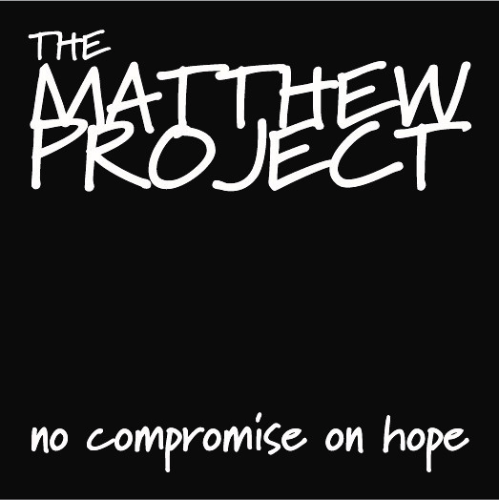
What is Quick Hit Volunteering?
Quick Hit Volunteering at The Matthew Project refers to easy, low commitment actions that take 1 minute to half a day complete. Our quick hit volunteers are amazing people who we can ask to do small tasks or facilitate an occasional workshop, sharing a skill or knowledge. Quick Hit Volunteering is ideal if you aren't able to commit to something longer term but want to help. You can make a big difference to our work by sparing just a few minutes and some can be done on the beach, whilst having a coffee, riding on the bus and even in your pyjamas!
You’ll find out about quick hit opportunities via email, WhatsApp, Twitter or on our Facebook page.
For more information please contact Sarah Nunn at sarah.nunn@matthewproject.org or 07810 656690.

Quick Hit Registration

Details
Full Name
Preferred name if different from above
Preferred pronoun | she/her  he/him  they/them  other
Phone (home)
Phone (mobile)
Email
Address

Postcode
Skills and Interests
(professional, personal attributes, hobbies etc.)

Are you fluent in a language other than English?  If YES, please tell us which. | YES/NO
We uphold the values of equal opportunities when recruiting volunteers, and welcome applications from all backgrounds. All information you supply in this form will be treated in confidence and in accordance with Data Protection Act legislation. Our Privacy Policy is available on our website. If you wish to be removed from our list of volunteers and/or stop receiving the newsletter at any time, please let us know.

What type of quick hit volunteering are you interested in?
- baking | - helping at events
- proofreading | - collections/deliveries
- providing feedback on resources | - helping secure items for auctions
- helping at a stall | - photography
- retweeting | - design
- passing on social media | - data entry
- advertising events | - mailshots
- testing webpages | - one off admin tasks
- sponsored activities | - gardening at Matthew Project premises
- looking after a collection box | - general upkeep of Matthew Project premises
- completing questionnaires | - TMP blogging/vlogging
- facilitating a one-off workshops (or 2-3 in a series) please state what the workshop would be: | - other please let us know if there is anything else you would like to do:
Code of Conduct
Quick Hit Volunteering at The Matthew Project is meant to be fun and low on bureaucracy. However, we still expect everyone at the Matthew Project, staff, volunteers, trustees and service users to respect you, and likewise, for you to respect every individual, the charity and everyone involved with us. This includes confidentiality and appropriate behaviour when volunteering. Please read the following Code of Conduct and tick to confirm that you will abide by it. If you wish to discuss any element of these, please contact us.

1) model and promote the Matthew Project’s commitment to safeguarding, confidentiality and respect for everyone in all aspects of your volunteering, including in the use of social media
2) not to exploit or abuse your position
3) follow the Matthew Project policies relating to confidentiality and information sharing and information governance (these are available for you to read if you wish to)
4) follow the Matthew Project’s procedures for reporting concerns or about the behaviour of an individual without delay
7) not make inappropriate, sexual or abusive remarks, including on social media
8) listen to and respect the views of others
9) recognise that people can be adversely affected by words and actions and to sensitively challenge inappropriate, offensive, racist or abusive language and behaviour, when safe and appropriate to do so.

- I AGREE TO THE CODE OF CONDUCT

Would you like to receive the Matthew Project Newsletter? YES / NO
Would you like to be included on the WhatsApp Quick Hit Volunteering Group? YES / NO
Signed
Date

